USABILITY EVALUATION AND PREDICTION OF FAKE NEWS USING PASSIVE AGGRESSIVE CLASSIFIER MACHINE LEARNING ALGORITHM

BY

ADEWALE OMOOBA F/HD/21/3210008
OGUN ADEWALE F/HD/21/3210019

A PROJECT SUBMITTED TO THE
DEPARTMENT OF COMPUTER TECHNOLOGY
SCHOOL OF TECHNOLOGY
YABA COLLEGE OF TECHNOLOGY,
YABA – LAGOS.

IN PARTIAL FULFILLMENT OF THE REQUIREMENTS FOR THE AWARD OF HIGHER NATIONAL DIPLOMA (HND) IN
COMPUTER SCIENCE

DECEMBER, 2023
CERTIFICATION
This is to certify that this project work titled, “USABILITY EVALUATION AND PREDICTION OF FAKE NEWS USING PASSIVE AGGRESSIVE CLASSIFIER MACHINE LEARNING ALGORITHM”, was carried out by ADEWALE IFEOLUWA BLESSING with Matriculation Number: F/HD/22/3210008, and OMOOBA QUAM GBOLAHAN with Matriculation Number: F/HD/22/3210019 under the supervision of Mr. ONADOKUN I.O., and submitted to the Department of Computer Technology, School of Technology, Yaba College of Technology, Yaba, Lagos, Nigeria in partial fulfillment of the requirement for the award of Higher National Diploma (HND) in Computer Science.

MR. ONADOKUN I. O. Date
Supervisor

DR. RUFAI M. M. Date
H.O.D (Computer Technology)

DEDICATION
We dedicate this project to God Almighty, the omniscience, who in His infinite mercy and love gave us the wisdom, knowledge and understanding to carry out this assignment. May His name be praised forever. We also dedicate this project to the Department of Computer Technology, for the opportunity to learn beyond the classroom and explore the academic fields of research.

ACKNOWLEDGEMENT
We appreciate every individual who contributed to the success and completion of this project. To our supervisor MR. ONADOKUN I.O. respectively, who served as our guide throughout this work, encouraging and challenging us to do better which enabled us to complete this project in confidence. To the research methods lecturers, Dr. (Mrs) Adetoba, B.T, Mr. Lawal, O.L, and Dr. Adigun, we thank you for educating us on the art of research and presentation. We also want to thank our course mates for the various ways they helped to the outcome of this project. We appreciate you. Thank you.

ABSTRACT
The proliferation of fake news has become a significant issue in today's digital age, as it can have a profound impact on public opinion and decision making. In order to tackle this problem, machine learning algorithms have been employed to automatically detect fake news. This project focuses on using a Passive Aggressive Classifier algorithm to predict fake news. The algorithm is trained on a dataset of news articles, using features such as text, metadata, and source information. The results of the experiments indicate that the Passive Aggressive Classifier is an effective tool for detecting fake news. The algorithm outperforms traditional machine learning algorithms in terms of accuracy, precision, and recall, demonstrating its potential for use in real-world applications. This project highlights the importance of incorporating various features in the training process, as well as the importance of considering the context in which news is spread. Furthermore, it sheds light on the need for ongoing research in the field of fake news detection to further improve the accuracy and robustness of machine learning algorithms. In conclusion, this project provides valuable insights into the use of Passive Aggressive Classifier for fake news prediction and has the potential to contribute to the development of more advanced solutions to this pressing issue.

TABLE OF CONTENTS
Title
Certification i
Dedication ii
Acknowledgment iii
Abstract iv
Table of Contents v
List of Figures ix
List of Tables xi

CHAPTER ONE: INTRODUCTION
1.1 Background of the Study 1
1.2 Statement of the Problem 3
1.3 Aim and Objectives of the Study 3
1.4 Significance of the Study 4
1.5 Scope of the Study 4
1.6 Limitations of the Study 6
1.7 Definition of Terms 6
CHAPTER TWO: LITERATURE REVIEW
2.1 Introduction 7
2.1.1 History of Fake News 8
2.1.2 Types of Fake News 9
2.1.3 Fake News Detection Using Naïve Bayes 9
2.1.4 Fake News Detection Using Support Vector Machine 10
2.2 Machine Learning 10
2.2.1 Machine Learning Applications 10
2.2.2 Machine Learning Approaches 12
2.2.2.1 Supervised Learning 13
2.2.2.2 Unsupervised Learning 17
2.2.2.3 Semi-supervised Learning 20
2.2.2.4 Reinforcement Learning 20
2.3 Theoretical Frameworks 21
2.3.1 Support Vector Machine 21
2.3.2 Logistic Regression 21
2.3.3 Passive Aggressive Classifier 22
2.4 Related Works 24
2.5 Summary of Research Gap 29
CHAPTER THREE: METHODOLOGY
3.1 Introduction 35
3.2 Research Design 35
3.3 Overview of Existing System 36
3.3.1 Benefit of the Existing System 36
3.3.2 Problems of the Existing System 36
3.4 Overview of New System 36
3.5 Analysis of Proposed System 37
3.5.1 Technologies Used 38
3.5.2 Dataset Information 38
3.5.3 Data Overview 39
3.6 Process Design for New System 41
3.6.1 Proposed System Model 41
3.6.2 Use Case Diagram 46
3.7 System Specification 46
CHAPTER FOUR: RESULTS AND DISCUSSION
4.1 Introduction 47
4.2 Results 47
4.2.1 Confusion Matrix for Support Vector Machine Algorithm 48
4.2.2 Confusion Matrix for Logistic Regression Algorithm 48
4.2.3 Confusion Matrix for Passive Aggressive Classifier Algorithm 49
4.2.4 Accuracy for Support Vector Machine (SVM) model 49
4.2.5 Accuracy for Logistic Regression (LR) model 50
4.2.6 Accuracy for Passive Aggressive Classifier (PAC) Model 50
4.2.7 Precision, Sensitivity and Specificity Evaluation 51
4.3 Discussion of Results 51
4.4 Conclusion 54
CHAPTER FIVE: SUMMARY, CONCLUSION AND RECOMMENDATION
5.1 Introduction 59
5.2 Summary 59
5.3 Conclusion 60
5.4 Recommendation 60
References

LIST OF FIGURES
Fig 2.0: Machine Learning Approaches 13
Fig 2.1: Classification Algorithm in machine learning 14
Fig 2.2 Regression algorithm in machine learning 15
Fig 2.3: Clustered data points 18
Fig 2.4: Association rule learning algorithm 19
Fig 2.5: Classifying by finding hyperplane 21
Fig 2.6: Logistic Regression graph 22
Fig 2.7: An illustration of the results obtained from various online solvers
using the dataset of handwritten digits 23
Fig 3.0: Sequence of the new system 37
Fig 3.1: Code used to import dataset from Kaggle 39
Fig 3.2: Label binarization 39
Fig 3.3: Data frames to be used 39
Fig 3.4: Code for stemming and removing stopwords 40
Fig 3.5: Code for vectorizing text data 40
Fig 3.6: Code of train-test-split on dataset 41
Fig 3.7: Process design flowchart of the proposed system 41
Fig 3.8: Model for new predictive system 45
Fig 3.9: Use case diagram for the new system 46

Fig 4.0: Performance of Support Vector Machine model on testing data 48
Fig 4.1: Performance of Logistic Regression model on testing data 48
Fig 4.2: Performance of Passive Aggressive Classifier model on testing data 49
Fig 4.3: Accuracy code snippet for SVM model 49
Fig 4.4: Accuracy code snippet for LR model 50
Fig 4.5: Accuracy code snippet for PAC model 50
Fig 4.6: Code for exporting the model 51
Fig 4.7: Code for default route of Flask website 52
Fig 4.8: Code snippet for index.html 52
Fig 4.9: Code snippet for predict route for the web app 53
Fig 4.9a: Code for importing trained model and vectorizer 53
Fig 4.9b: User enters news content that is likely to be fake 54
Fig 4.9c: Web application result (for Fake news) 55
Fig 4.9d: News headline related to USA politics 56
Fig 4.9e: User enters news content that is likely to be real from Fig 4.3 57
Fig 4.9f: Web application result (for Real news) 58

LIST OF TABLES
Fig 2.0 Summary of research gap 29
Fig 3.0 Columns in the dataset 38
Fig 4.0 Summary of evaluation metrics 51
CHAPTER ONE
INTRODUCTION
1.1 Background of the Study
False information presented as news is referred to as fake news. It is frequently employed to damage the reputation of an individual or an organization or to generate income from advertising. Fake news was once common in print, but its prevalence has increased with the rise of social media, particularly the Facebook News Feed. Various types of fake news about the candidates spread widely in online social networks during the 2016 US presidential election, potentially having a significant impact on the election results.
Fake news has grown enormously in recent years, and this growth has had a significant impact on how we make a variety of sensitive decisions on a daily basis, including deciding who will be our President (Okoro et al., 2018).
Today's world is awash in data and information about current events and news. People nowadays have easy access to information thanks to modern communication technology. This also implies that data is generated in large quantities by millions of people who have access to the internet, particularly social media. Data access is not a problem, but it is dangerous when that data contains fake news or stories that spread globally. This fake news can cause confusion and even political tension, and it has an immoral impact on personal and social life (Hossain et al., 2021).
Events like (Kang & Goldman, 2016), in which a man attacked a pizzeria as a result of a widely circulated fake news article, demonstrate the harmful effects of fake news, as previously defined. This incident, along with research from (Domonoske, 2016), shows that people aren't very good at spotting fake news—possibly no better than chance. Therefore, the question of whether or not machines can perform a task better still exists.
Two approaches could be used by machines to try to outperform humans in tackling the fake news issue. The first is that machines are more adept than people at spotting and tracking statistics. For instance, a machine can more easily recognize the most frequently used words in a news article. Furthermore, machines might be more effective at searching through a knowledge base to find all pertinent articles and providing answers based on those numerous sources.
Either of these approaches might be effective at identifying fake news, but we chose to concentrate on how supervised learning, which only extract features from the language and content of the source in question and does not use a fact-checker or knowledge base, can help a computer solve the fake news problem.
The task would essentially be the same as what a person would encounter when reading a newspaper article on paper without internet access or background knowledge (as opposed to reading something online where he can easily look up relevant sources). The computer must employ methods that do not rely on author and source blacklists because it will only have access to the words in the article.
The current project involves the use of artificial intelligence (AI), machine learning (ML) and natural language processing (NLP) techniques to develop a model that can identify documents that are likely to be fake news articles. Many of the current automated solutions to this problem revolve around a blacklist of known fake news authors and sources (Agarwal et al., 2019). But what happens when the author is anonymous or when false information is published by a generally trusted source? In these situations, it is necessary to simply rely on the news article's content to determine whether or not it is fake. It should be possible to accurately categorize fake news articles by gathering examples of both real and fake news and training a model.
The research focuses on using the Fake and Real News dataset from Kaggle and machine learning classification algorithms like Logistic Regression, SVM and PassiveAggressive Classifiers.
The Fake and Real News dataset is freely accessible via the Kaggle website (Bisaillon, 2020). The dataset contains two text files, which contains a list of articles considered as fake news and real news.
In this project, various feature engineering techniques for text data have been used, such as the TF-IDF vectorizer and the word embedding model, to turn the text data into feature vectors that are then sent to machine learning algorithms to determine whether or not the news is fake. We will categorize news as fake or real using various features and classification algorithms, and we will determine whether the news is fake or real using the feature extraction method and algorithm that produces the best results.
We will ignore attributes such as the source of the news, whether it was reported online or in print, and so on in this project, focusing solely on the content being reported.
1.2 Statement of the Problem
The spread of fake news has become a significant problem in our digital age, affecting public opinion and decision making. With the increasing availability of technology, it has become easier to spread false information, making it challenging to detect and prevent. Traditional methods of verification and fact-checking are time-consuming and may not be effective in preventing the spread of false information in real-time. In response to this growing concern, machine learning algorithms have been employed to automatically detect fake news. However, current solutions have limitations, including low accuracy and the inability to effectively distinguish between real and fake news. This project aims to address these limitations by proposing a novel approach to fake news prediction using the Passive Aggressive Classifier machine learning algorithm. The goal of this project is to develop a predictive model that can accurately distinguish between real and fake news, providing a tool to combat the spread of false information. This project will evaluate the effectiveness of the Passive Aggressive Classifier algorithm in detecting fake news and provide insights into the importance of incorporating various features in the training process and considering the context in which news is spread.
1.3 Aim and Objectives of the Study
The aim of this project is to determine the usability evaluation and prediction of fake news using passive aggressive classifier machine learning algorithm.
The objectives are:
- To develop a machine learning model for predicting fake news using
- To implement the above algorithm by deploying the model as a web application
- To evaluate the proposed system
1.4 Significance of the Study
The spread of fake news has become a major issue in our society, affecting public opinion and decision making. The increasing availability of technology has made it easier to spread false information, making it difficult to detect and prevent. Traditional methods of verification and fact-checking are time-consuming and may not be effective in preventing the spread of false information in real-time. This has led to a growing need for automatic and scalable solutions to detect fake news.
The significance of this study lies in its contribution to the development of more advanced solutions to combat the spread of fake news. The proposed approach of using the Passive Aggressive Classifier machine learning algorithm has the potential to provide a more accurate and scalable solution compared to current methods. The results of this study will provide insights into the effectiveness of the algorithm in detecting fake news, as well as the importance of incorporating various features in the training process and considering the context in which news is spread. This study has the potential to serve as a starting point for further research in the field of fake news detection, leading to the development of more robust and accurate solutions.
In conclusion, this study is significant as it sheds light on the potential of machine learning algorithms in detecting fake news and has the potential to make a significant impact in the ongoing battle against false information.
1.5 Scope of the Study
The scope of this project focuses on building a useful AI model to evaluate the prediction of fake news using machine learning classification algorithms. The spread of fake news, one of the most pervasive hazards, will be fought off in part by this project, which will help to spark a new revolution. The same will be eradicated from the ground up as a result. With the help of this project, citizens will become more responsible and aware of current issues. By completing this project, a nation's citizens will be better equipped to make important choices.

1.6 Limitations of the Study
The main limitation of this study is that there is no existing local dataset for detecting fake news articles. Furthermore, local news organizations do not believe it is necessary to curate a dataset to combat fake news because they actively contribute to its spread, resulting in no practical way to obtain their dataset. Other constraints include the school administration's limited time for project work.
1.7 Definition of Terms
Fake News: Fake news is a news article that is intentionally and verifiable false
Prediction: A prediction is an assertion about information or an upcoming event
Dataset: is a set of data in form of a table or CSV file

AI: The simulation of human intelligence functions by machines, particularly computer systems, is known as artificial intelligence. Expert systems, natural language processing, speech recognition, and machine vision are some examples of specific AI applications.

ML: Machine learning is a subfield of artificial intelligence (AI) and computer science that focuses on using data and algorithms to mimic human learning processes and progressively increase accuracy.

Tokenization: Tokenization divides text-based unstructured data into informational units that may be counted as discrete items. An unstructured string i.e., text document is instantly transformed into more useful data that can be subsequently structured to make it better suited for machine learning.

Stopwords: Stopwords are words like a, an, the, be, etc. that don't offer any additional information to a sentence; these words frequently cause noise while modeling.

Stemming: Stemming uses a series of principles, such as unit "ed" if words end in "ed," to assist construct groups of words with related meanings.
Vectorization: This is process of converting natural language processing text into numbers.

TD-IDF: The acronym TF-IDF stands for term frequency-inverse document frequency. It is a statistical tool used to assess a word's significance to a document in a collection.

CHAPTER TWO
LITERATURE REVIEW
2.1 Introduction
Information sharing is now simple in a world of continually evolving technologies. There is no denying that the internet has made life easier and given us access to a wealth of knowledge. These days, anyone can create content that the entire world may access. Unfortunately, fake news attracts a lot of attention online, particularly on social media. People fall for deception and don't hesitate to spread such false information to others. This kind of news disappears, but not before it has caused the harm it was designed to specifically, in urgent times like actual catastrophes, the propagation of unintentional or purposeful misinformation on social media can have detrimental effects on society. This makes it easier for rumors to circulate on social media. Users of social media trade and share the most recent information with a wide audience, including a ton of new information every second. However, publishing current news on social media is not always accurate (Ahmad et al., 2020). News websites and social networking platforms like Facebook, Twitter, and WhatsApp are important sources of these false reports. In addition to highlighting the risks associated with fake news' consequences, the growth of fake news during the 2016 U.S. Presidential Election also brought to light the difficulties associated in separating fake from legitimate news. When deliberate misinformation or hoaxes are disseminated through traditional print and broadcast news media as well as online social media, it is referred to as fake news, a form of yellow journalism or propaganda (Khan et al., 2021). While the term fake news may be recent, the phenomena itself is not. The effects of fake news are wreaking havoc around the world. When an image of the Quran was posted online in 2012, numerous pagodas in Bangladesh were set on fire. Despite being associated with the shot, the young Buddhist was in no way responsible for it. Despite the fact that it was unable to confirm the identity of the image, many rumors spread as a result of it (Hossain et al., 2021).
On websites and in general, social media, fake news has been spread through a variety of tactics. One of the technologies that is used to propagate false information is social bots. Super-users are occasionally the target of bots that add replies and mentions to postings. These actions lure others into spreading the misleading news pieces. Clickbait is yet another technique used to propagate false information. Clickbait is a marketing technique intended to grab people' attention. News or headlines that are sensational are frequently used as clickbait to direct users to adverts. More advertisement clicks equal more revenue.

An in-depth knowledge of fake news and its sources is necessary to begin addressing this issue. Only after that can one begin to investigate the many approaches and disciplines of machine learning (ML), natural language processing (NLP), and artificial intelligence (AI) that may be able to assist in combating this issue. Large IT corporations and computer science students have recently started trying to stop the spread of false information on the internet. Both Google and Facebook announced that they would fight the spread of fake news on their own platforms. By limiting advertising to purposefully deceptive websites, Google is prepared to implement policy changes that will remove the financial incentives to spread false information. Facebook is taking a similar stance on policy.

2.1.1 History of Fake News
There has always been fake news. History is full with instances when people have twisted the facts for personal gain, which is called lying, or for political gain, which is called propaganda. The employment of fake news by Octavian against Marc Anthony to launch the last war of the Roman Republic is one of the first known instances (32 BC to 30 BC). There were many similarities to today's elections. Marc Anthony was supported by Cleopatra on one side, and Octavian, Julius Caesar's adopted son, was on the other. Octavian used brief statements inscribed on coins to disparage Anthony as an Egyptian puppet, a traitor to Rome, a philanderer, and a drunk (Watts, 2018). Obama Signs Executive Order Banning the Pledge of Allegiance in Schools Nationwide was the top-performing fake news article on Facebook in 2016, according to BuzzFeed News analysis. It was published on a fake news website designed to seem like ABC News, and in just two months, it received over 2.1 million shares, comments, and responses. And to make matters worse, the top-performing fake election news items on Facebook over the final three months of the US presidential campaign attracted more engagement than the top stories from all 19 major news agencies put together. BuzzFeed's study of more than 3,000 US adults found that fake news headlines succeeded in tricking people around 75% of the time. People who use Facebook as their primary news source are more likely to believe fake news headlines to be real than people who don't. Michael P. Lynch, a philosophy professor at the University of Connecticut, claims that the internet is frequently both the best fact-checker and bias-confirmer in the world.
2.1.2 Types of Fake News
Following are seven distinct types of fake news that First Draft News' Claire Wardle has identified (Wardle, 2021):
- False connections: take place when the headlines, images, or captions don't support the facts.
- False contextual information: may accompany actual content to create misleading content.
- Impostor content: When made-up or fake sources impersonate real ones.
- Satire and parody: are two examples of content that may deceive viewers but has no malicious intent.
- Changed content: A photograph that has been altered is a good example
- Fabricated content: This refers to fresh information that is completely false and meant to hurt or deceive.
- False context: occurs when the proper content is shared with the wrong context.

2.1.3 Fake News Detection Using Naïve Bayes
In artificial intelligence, simple machine learning includes Naive Bayes classifiers. With the help of multinomial NB and pipelining ideas, the widely used Naive Bayes algorithm determines if a piece of news is accurate or not. It is not the only approach for training these classifiers since many other algorithms also concentrate on common principles. Using nave Bayes, it is possible to determine whether the news is authentic or fraudulent. Text categorization uses this particular type of method. With the help of a naive Bayes classifier, token usage is connected to news that may or may not be false, and the Bayes theorem is then used to determine the news' accuracy. The Naive Bayes rule is based on the following Bayesian theorem:
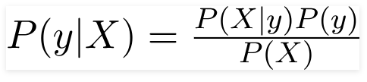
Source: Naïve Bayesian theorem.

2.1.4 Fake News Detection Using Support Vector Machine
Support-vector machines (SVM) are supervised learning models with corresponding learning algorithms that examine data for regression and classification in machine learning. A technique known as support vector machines finds the best distinction between vectors that are a part of a group and those that are not. Any type of vector that encodes any kind of data can use it. This means that texts must be converted into vectors in order to fully utilize the capability of Support Vector Machine text classification.
2.2 Machine Learning
Nvidia defines machine learning as the process of utilizing algorithms to analyze data, learn from it, and then determine or predict something about the outside world. The machine is thus "trained" using vast amounts of data and algorithms that enable it to learn how to complete the work, as opposed to being manually programmed with a specific set of instructions to carry out a certain operation (Copeland, 2021). The method through which computers can take an algorithm (also known as rules-based programming) and improve it as they interact with more data is called machine learning. You may provide computers terabytes and petabytes of data with the aid of machine learning so they can discover distinctions and develop their own algorithms based on the underlying human-driven programming to achieve the desired result.
Machine learning is widely used to predict fake news. Machine learning, which enables systems to automatically learn from their experiences and improve over time without having to be explicitly designed, uses artificial intelligence (AI). Machine learning is the process of creating computer programs that can access data and utilize it to learn for themselves. The learning process begins with observations or data, such as examples, firsthand experience, or teaching, in order to uncover patterns in data and enhance decisions made in the future based on the examples we provide. The basic objective is to enable computers to learn independently of humans and modify their behavior as a result.
2.2.1 Machine Learning Applications
Machine learning, which is rapidly gaining prominence, is the foundation of modern technology. The uses of machine learning in the actual world are as follows:
- Financial chatbots: The use of machine learning and artificial intelligence in the banking industry has also led to automation. By gaining access to the necessary data, machine learning models can generate an intelligent analysis of internal patterns that supports future decision-making. These models frequently provide recommendations for potential future courses of action to assist in making the business choice in the most effective and efficient way feasible. Financial apps powered by AI may swiftly learn from their previous actions and reduce errors, which reduces the loss of time and other important resources. In addition to automating a lot of tedious duties in a financial institution, AI chatbots provide a beneficial form of consumer contact (Yu et al., 2021).

- Loan and Insurance Underwriting: To obtain a competitive advantage, financial organizations can use apply machine learning models on a wide scale to underwrite loans, credit, and insurance (Eling et al., 2021). When developing powerful machine learning models, large banks and insurance businesses can profit from the availability of historical consumer data, financial lending and borrowing data, insurance results, and data connected to default in paying debts. When evaluating and lending risks, the learning algorithms can use the observed patterns and trends to lower future defaults. The use of such models could lead to a paradigm change in the profitability and effectiveness of corporations.

- Fraud analysis and detection: Fraud analysis and detection is one of the most significant machine learning applications in the banking industry. Sensitive information from both the organizational and personal fronts is subject to an elevated level of security and privacy risk due to the pervasive availability of connectivity, high processing capacity in devices, and a growth in the amount of data stored and communicated online. These issues have changed how online fraud analysis and detection are carried out. Recent approaches to detection are more resilient and agile than older approaches that relied on matching a large number of complex rules because they execute learning algorithms that adapt to new security risks (Dornadula & Geetha, 2019).

- Loan and Insurance Underwriting: To obtain a competitive advantage, financial organizations can use apply machine learning models on a wide scale to underwrite loans, credit, and insurance (Eling et al., 2021). When developing powerful machine learning models, large banks and insurance businesses can profit from the availability of historical consumer data, financial lending and borrowing data, insurance results, and data connected to default in paying debts. When evaluating and lending risks, the learning algorithms can use the observed patterns and trends to lower future defaults. The use of such models could lead to a paradigm change in the profitability and effectiveness of corporations.

- Risk Modeling: One of the main uses of machine learning models and algorithms is in the broad subject of risk modeling and management (Paltrinieri et al., 2019). For the credit and risk modeling sectors, machine learning is essential. The majority of classification techniques and modeling approaches used in machine learning, such as binary logistic regression, multinomial logistic regression, linear and quadratic discriminant analysis, decision trees, etc., are the fundamental building blocks of applied modeling in the real world.

- Fraud analysis and detection: Fraud analysis and detection is one of the most significant machine learning applications in the banking industry. Sensitive information from both the organizational and personal fronts is subject to an elevated level of security and privacy risk due to the pervasive availability of connectivity, high processing capacity in devices, and a growth in the amount of data stored and communicated online. These issues have changed how online fraud analysis and detection are carried out. Recent approaches to detection are more resilient and agile than older approaches that relied on matching a large number of complex rules because they execute learning algorithms that adapt to new security risks.
2.2.2 Machine Learning Approaches
There are numerous various strategies that can be applied when undertaking machine learning. Unsupervised, semi-supervised, supervised, and reinforced learning are the standard classifications used to group them.
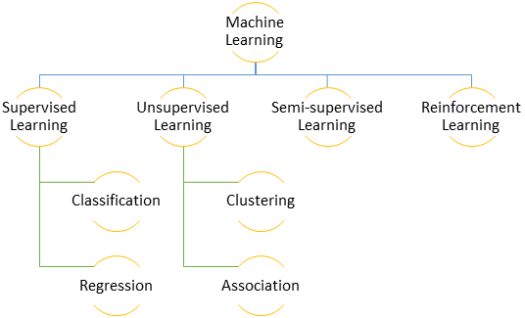
Fig 2.0: Machine Learning Approaches
2.2.2.1 Supervised Learning
To identify the rules that translate a set of inputs to a set of outputs is the goal of supervised learning. Algorithms for supervised machine learning can use what they have learnt in the past to predict future events using tagged examples and fresh data. Starting from the analysis of a well-known training dataset, the learning algorithm constructs an inferred function to predict the values of the outputs. The system is capable of producing targets for any new input after receiving enough training. In order to find faults and make any necessary model corrections, the learning algorithm can also compare its results to the desired, accurate results. The learning process is supervised because example labelled data from prior input and output pairs are given to the model to teach it how to behave. Supervised learning is the term used to describe the machine learning task of learning a function that maps an input to an output based on sample input-output pairs. From labeled training data, which consists of a collection of training instances, it infers a function. Two types of supervised learning exist:
Classification
Similar data points are categorized by being divided into various sections using classification. The rules that specify how to divide the different data pieces are found using machine learning. Simply said, categorization approaches look for the optimal way to draw a line that divides data points. The distinctions between classes are marked by the decision boundaries. The entire area selected to designate a class is referred to as the decision surface. A data point is classified into a certain class if it is contained inside the decision surface's borders.
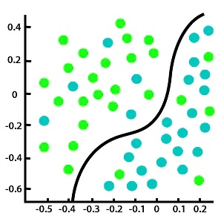
Fig 2.1: Classification algorithm in machine learning
Source: https://www.javatpoint.com/classification-algorithm-in-machine-learning
Types of Classification Problems
- Binary Classification: There are two categories into which this classification issue can be divided. For instance, to categorize an email as spam or not spam, we can assign labels 0 for spam and 1 for not spam, which will similarly change the output probabilities to either of these labels, making it a binary classification task.

- Multi-Class Classification: In this case, classification may come from more than two classes. Assume we have historical weather data for a location where each day is classified as either sunny, cloudy, or wet. In such situation, we can train a model and apply it to forecast the weather for tomorrow, which may fall into any of the aforementioned categories. Multi-class classification is demonstrated in this case.
- Multi-Label Classification: Let's look at an illustration of semantic tagging. The goal of semantic tagging is to examine some text data and foretell the text's content groups. For instance, a news article about government rules on Covid-19 can be categorized as law, political, or healthcare. Accordingly, a multi-label classification problem arises when a single input can be classified into one, two, or more categories.

Examples of Classification Algorithms
- Naïve Bayes
- Support Vector Machine
- Stochastic Gradient Descent
- Logistic Regression
- Random Forest
Applications of Classification Algorithms
- Malware classification
- Web text classification
- Anomaly detection
- Customer churn prediction etc.
Regression
A subset of machine learning algorithms that are in the family of supervised machine learning algorithms are regression algorithms. The capacity of supervised learning algorithms to forecast the value of fresh data by simulating dependencies and interactions between the intended output and input properties is one of its fundamental features. Regression algorithms forecast the values of the output by using input attributes from the data provided into the system. According to protocol, the algorithm builds a model from the traits of training data and uses that model to predict the value of fresh data.
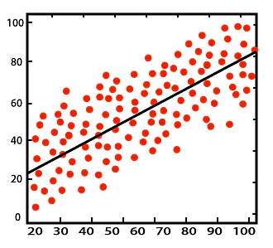
Fig 2.2: Regression algorithm in machine learning
Source: https://www.simplilearn.com/regression-vs-classification-in-machine-learning-article
Regression produces a number rather than a class, which is how it differs from classification. Regression is the process of figuring out how closely two independent and dependent variables are correlated. It assists in making predictions about continuous variables like market trends, home prices, and so forth. The method predicts a single output value using training data. On the basis of training data, regression can be used to forecast house prices, for instance. The input variables will be location, home size, and so forth.

Types of Regression Algorithms
- Simple Linear Regression: A mapping function is used in simple linear regression to model the linear relationship between an independent variable and a dependent variable that must be predicted. Consider, for illustration, that a locality's housing costs are only influenced by its geography. So, basing the trained model on historical data, one may forecast home costs given the area of any new region.

- Multiple Linear Regression: Regression analysis using many independent variables and one dependent variable is known as multiple linear regression. For instance, a restaurant's evaluations are influenced by the caliber of the food as well as the ambiance, service, and location. Therefore, in this situation, several independent variables affect the dependent parameter linearly.

- Polynomial Regression: The non-linear relationship between the independent and dependent variables is mapped by the polynomial regression procedure. The equation is not linear since the mapping consists of many powers of an independent variable. This kind of algorithm, for instance, can be used to forecast the number of Covid-19 cases. Polynomial regression can map the non-linearity and forecast since the growth or reduction in cases is not linearly connected to the number of persons wearing masks.
Applications of Regression Algorithms
- Predicting the behavior of customers
- Prediction of stock rates
- Performing analysis on survey data
Advantages of Supervised Learning
- You will have a comprehensive understanding of the classes of the training data.
- You can define the classes in great detail by training the classifier so that it has a flawless decision boundary that accurately distinguishes between various classes.
- The specific number of classes can be determined before supplying the data for training.
- After the training is finished, you don't necessarily need to keep the training data in your memory. The mathematical expression for the decision boundary can still be used.

Disadvantages of Supervised Learning
- For a variety of reasons, supervised learning cannot handle some of the more difficult machine learning tasks.
- Supervised learning is unable to extract unknown information from training data, in contrast to unsupervised learning.
- In contrast to unsupervised learning, it is unable to classify or organize data by figuring out its features on its own.
- The output can have the wrong class label if we offer a classification input that does not correspond to one of the classes in the training data. Consider training an image classifier with data on cats and dogs as an example. The outcome may then be a cat or a dog, which is incorrect, if you enter an image of a giraffe.

2.2.2.2 Unsupervised Learning
Unsupervised learning is the process of teaching a computer to act on unlabeled data without human supervision. The machine's job in this scenario is to categorize unsorted data based on similarities, patterns, and differences without any prior data training. In contrast to supervised learning, unsupervised learning does not result in the machine being educated. As a result, the machine can only successfully locate the hidden structure in unlabeled data on its own. This model works independently to uncover previously unnoticed patterns and data. It mostly makes use of unlabeled data. Unsupervised machine learning methods are applied when the training data is neither categorized nor labeled. Unsupervised learning typically comes in two forms:

Clustering
Unsupervised learning is largely used in clustering. When individuals in a group are more similar to one another than to those in other clusters, this process of grouping is known as clustering. There are many different clustering methods available. They typically use a type of similarity meter based on specific metrics, such as Euclidean or probabilistic distance. Genetic clustering, bioinformatic sequence analysis, pattern mining, and object recognition are a few clustering problems that can be resolved utilizing the unsupervised learning approach. Clustering is the process of forming groups with recognizable traits. Clustering is used to look for several subgroups in a dataset. In unsupervised learning, we are not limited by any set of labels in terms of how many clusters we can build.
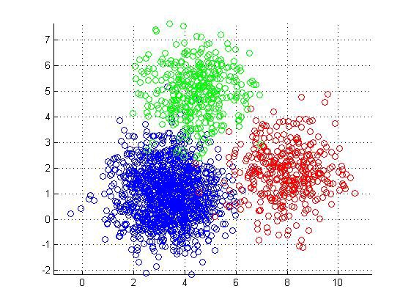
Fig 2.3: Clustered data points
Source: https://www.kdnuggets.com/2019/09/hierarchical-clustering.html
Types of Clustering Algorithms
- Grid-based Clustering
- Distribution-based Clustering
- Density-based Clustering
- Hierarchical Clustering
- K-Means Clustering
- Centroid Clustering
Applications of Clustering Algorithms
- Pattern recognition
- Image processing
- Market research
- Data analysis
Association
Association learning is a rule-based machine learning technique for finding pertinent associations between variables in huge databases. By using some indicators of interest, it aims to find reliable rules in databases. In association learning, you aim to identify the rules that best describe your data. As an illustration, it's probable that someone who sees video A will also watch video B. Association rules are perfect in cases like this when you want to find similar products.
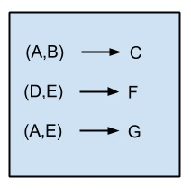
Fig 2.4: Association rule learning algorithm
Source: https://medium.com/@Shaier/ml-algorithms-one-sd-%CF%83-association-rule-learning-algorithms-b35303e215d
Types of Association Algorithms
- F-P Growth Algorithm
- Apriori Algorithm
- Eclat Algorithm

Applications of Clustering Algorithms
- Protein sequence
- Basket data analysis
- Web usage mining
- Medical Diagnosis

2.2.2.3 Semi-supervised Learning
A significant amount of unlabeled data is combined with a modest amount of labeled data during training as part of the machine learning technique known as semi-supervised learning. Semi-supervised learning lies in the middle between supervised and unsupervised learning. Clustering the unlabeled data is often how semi-supervised learning is started. The labeled data are then used to label the clustered unlabeled data. Finally, a large volume of now-labeled data is used to train machine learning models. Semi-supervised learning models have the potential to be very successful because they can use a lot of data. Semi-supervised learning models are often created by combining the existing machine learning algorithms used in supervised and unsupervised learning with modified and altered versions. This technique is used in areas like content classification and speech analysis.

2.2.2.4 Reinforcement Learning
Even though the final type of machine learning is the most difficult and unusual, it has generated remarkable results. It educates through rewards rather than labels in the conventional sense. Actions that intelligent agents should do in a specific environment to optimize the concept of cumulative reward are taken into consideration in the machine learning discipline known as reinforcement learning. This is extremely similar to how people learn. Positive and negative impulses are constantly around us, and we take them and apply them to our life. These signals reach us in a variety of ways, including by way of the brain chemicals. When something positive happens, the neurons in our brains release dopamine and other elevating neurotransmitters, making us feel good and increasing our inclination to repeat the positive occurrence. We don't always require supervision, as contrast to supervised learning. Even when reinforcement signals are only seldom supplied, we can still learn quite well.
2.3 Theoretical Frameworks
2.3.1 Support Vector Machines (SVM)
A supervised machine learning approach called the Support Vector Machine (SVM) can be applied to classification or regression problems. However, classification issues are where it is most frequently utilized. When using the SVM algorithm, each data point is represented as a point in n-dimensional space (where n is the number of features you have), with each feature's value being the value of a certain coordinate. Next, we perform classification by identifying the hyper-plane that effectively distinguishes the two classes.
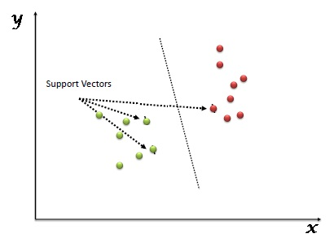
Fig 2.5: Classifying by finding hyper-plane
Source: https://github.com/Rajat2712/SVM
Simply put, support vectors are an individual observation's coordinates. The SVM classifier is a frontier that divides the two classes most effectively.
2.3.2 Logistic Regression
An illustration of supervised learning is logistic regression. It is used to determine or forecast the likelihood that a binary (yes/no) event will occur. One use of machine learning to identify whether a person is likely to have the COVID-19 virus or not is an example of logistic regression. Binary classification refers to the fact that there are only two answers to this question: either they are infected or they are not.
In this hypothetical illustration, the likelihood that a person may contract COVID-19 could depend on the viral load, the symptoms, the existence of antibodies, etc. Our factors (Independent Variables) would include the viral load, symptoms, and antibodies, and these would have an impact on our result (Dependent Variable).
To determine the likelihood of a target variable, a classification procedure called logistic regression is applied. There are only two viable classes since the goal or dependent variable is dichotomous in nature. The dependent variable is, to put it simply, a binary variable, meaning that data is coded as either 1 (which represents success/yes) or 0 (which represents failure/no). Mathematically, a logistic regression model forecasts P(Y=1) as a function of X. One of the simplest ML methods, it may be applied to a variety of classification issues as spam identification, diabetes prediction, cancer detection, etc.
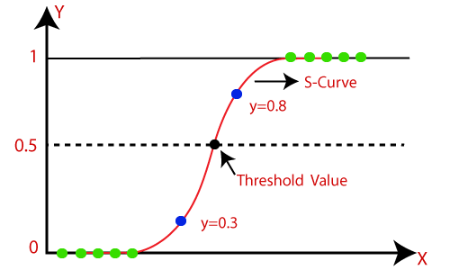
Fig 2.6: Logistic regression graph
Source: https://tutorialforbeginner.com/logistic-regression-in-machine-learning
2.3.3 PassiveAggressive Classifier
A family of machine learning algorithms known as passive-aggressive algorithms is not well-known to beginners or even intermediate Machine Learning aficionados. For some applications, they can be extremely helpful and effective, nevertheless. Large-scale learning typically uses passive-aggressive algorithms. One of the few online-learning algorithms is this one. As opposed to batch learning, when the full training dataset is used at once, online machine learning techniques employ sequential input data and update the machine learning model one step at a time. This is especially helpful when there is a large amount of data and training the complete dataset would be computationally impossible due to the magnitude of the data. Simply put, an algorithm for online learning will acquire a training example, update the classifier, and then discard the sample.
Finding fake news on a social media platform like Twitter, where new information is being published every second, would be a very good illustration of this. It would be excellent to use an online-learning algorithm to dynamically read Twitter data continuously because the amount of data would be enormous. In that they don't require a learning rate, passive-aggressive algorithms are somewhat comparable to Perceptron models. A regularization parameter is present, though.
For the following reasons, passive-aggressive algorithms are so named:
- Passive: Maintain the model as-is and make no adjustments if the prediction proves accurate. This means that the example's data is insufficient to alter the model in any way.
- Aggressive: If the forecast proves to be false, modify the model. Hence, a model modification could resolve the issue.
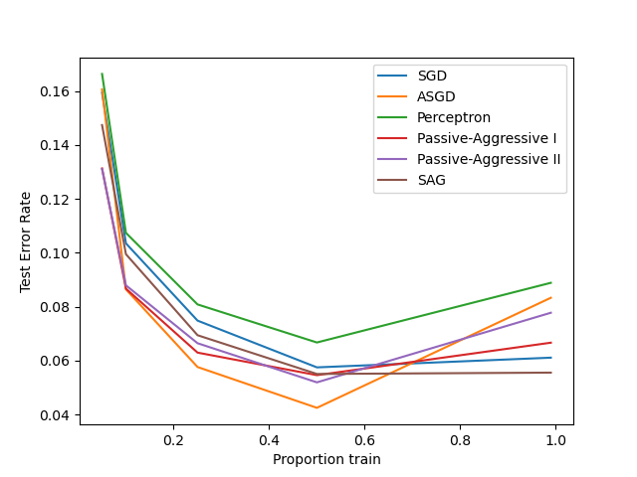
Fig 2.7: An illustration of the results obtained from various online solvers using the dataset of handwritten digits
Source: https://www.researchgate.net/figure/Results-for-the-MNIST-handwritten-digits-recognition-task-comparing-SVM-trained-on_fig1_221617993

2.4 Related Works
A wide variety of machine learning techniques are available for the detection of fake news. Several machine learning techniques, such as Logistic Regression, Decision Trees, Passive Aggressive, and Support Vector Machines (SVM). Many datasets, including the Kaggle Fake News Dataset, have been utilized in research on this subject. By removing and selecting different attributes from these databases, authors successfully come to a conclusion with their research. These studies are significant ones.
Wang et al. (2022). "FMFN: Fine-Grained Multimodal Fusion Networks for Fake News Detection" introduced a brand-new fine-grained multimodal fusion network (FMFN) to completely fuse textual and visual information for fake news detection. For a tweet that contained both text and an image, deep CNNs were used to extract a variety of visual attributes from the image, while a pretrained language model was used to extract word embeddings from the text. The textual and visual aspects were both enhanced and combined using the scaled dot-product attention. A public Weibo dataset was used in experiments to show how effective FMFN is. FMFN produced results that were competitive with those of other techniques for combining the text representation and the visual representation. It demonstrated that for identifying fake news, the joint representation obtained by fusing a visual representation and a text representation is superior than the joint representation learned by the FMFN, which fuses multiple visual features and multiple textual characteristics.

Ahmad et al. (2022) “Efficient Fake News Detection Mechanism Using Enhanced Deep Learning Model” presented a fresh set of features for Twitter rumor identification using a deep learning framework. Their method learns Bi-LSTM RNN models using the variation of aggregated data over several time intervals associated with each event. They found that their model outperformed the most recent techniques when they compared it to baseline LSTM-RNN widely employed recurrent units, tanh, and LSTM. To further improve Bi-LSTM RNN, more hidden layers and embedding layers were added. They also generated a fresh set of parameters and compared the outcomes to the best-in-class starting point.

Lai et al. (2022) “Fake News Classification Based on Content Level Features” using an open, sizable, and labeled Twitter dataset, combined ML and NLP to categorize fake news. On the basis of content-only features, they compare a number of cutting-edge ML and neural network models. Word embedding was used in neural network training while term frequency-inverse document frequency (TF-IDF) characteristics were implemented in ML training to improve classification performance. All of the conventional models achieved higher than 85% accuracy by using ML and NLP techniques. More than 90% accuracy was achieved by all neural network models. According to the study, neural network models perform better than conventional ML models by an average of about 6% precision, with all neural network models capable of up to 90% accuracy.

Raza & Ding (2022) “Fake news detection based on news content and social contexts: a transformer-based approach” described an innovative deep neural framework for false news identification. They discovered and addressed two particular issues with early false news detection and label shortage. For the detection portion, they created a special Transformer model that drew inspiration from the BART architecture. Their model's encoder blocks carried out the representation learning task. The decoder blocks forecast future behavior based on historical observations, which also assisted them in overcoming the difficulties of early fake news detection. The functionality of the encoders was necessary for the decoders. Therefore, both modules were crucial for identifying fake news.

Khanam et al. (2021) “Fake News Detection Using Machine Learning Approaches” emphasized the need of identifying fake news by analyzing it in two stages: categorization and disclosure. In the initial phase, social media emphasizes the fundamental ideas and tenets of fake news. In the discovery phase, various supervised learning algorithms are used to assess the existing techniques for fake news detection. They believed that expanding these features and applying random forest will give further improvements to the precession outcomes. Their research is dependent on the addition of numerical statistical data as features.

Khan et al. (2021) “A Benchmark Study of Machine Learning Models for Online Fake News Detection” gathered the largest and most varied dataset to compare the effectiveness of various applicable machine learning algorithms. To the best of their knowledge, they investigated a variety of sophisticated pre-trained language models for fake news identification in addition to the standard and deep learning ones and compared their performances from various angles for the first time. They discovered that pre-trained models like BERT and others do the best job of detecting fake news, especially with very little data. As a result, these models offer a vastly superior alternative for languages with little electronic content, or training data. Additionally, they performed a number of analyses depending on the models' performance, the article's subject and length, and they explained the various lessons they had learnt. They think that the benchmark study will aid the research community in its further exploration and assist news websites and blogs in choosing the best fake news detection technique.

Hossain et al. (2021) “A Study Towards Bangla Fake News Detection Using Machine Learning and Deep Learning” used a dataset trained with 57,000 Bangla news items linked to trustworthiness and counterfeit to identify Bangla fake news articles. K-fold cross-validation was used in this work to find 95% and 94% accuracy on top of the Bi-LSTM with Glove and FastText model. At the time, the research utilized a cutting-edge technology called a Gated Recurrent Unit (GRU), and the accuracy was reported to be 77%. They also calculated an accuracy of 96% using the Bi-LSTM, which is exactly what our suggested model shows. This study presents a detailed demonstration of some experimental analysis based on the FEM.

Preston et al. (2021) “Detecting fake news on Facebook: The role of emotional intelligence” evaluated if fake news detection, emotional intelligence, and educational attainment were associated with one another. Using a unique false news detection tool, they demonstrated that people with high emotional intelligence and university degrees are less likely to believe fake news than people with low EQ and school-college degrees. Their qualitative research also shed further light on why some people believe fake news, such as when the information confirms their preconceived notions. They concluded by outlining the ways in which their research could, in the short and medium terms, improve false news identification.

Mazzeo et al (2021). “Detection of Fake News on COVID-19 on Web Search Engines” created a model to identify potentially deceptive and false materials. They employed re-sampling approaches for class imbalance using a real-world dataset related to the recent COVID-19 outbreak, and then they used pre-existing machine learning algorithms to classify unreliable news. They demonstrate how the proposed methods, which are widely used in phishing and malicious URL detection, can increase the effectiveness and performance of classifiers by extracting lexical and host-based features from related uniform resource locators (URLs) for news articles.

Silva et al. (2020). “Intelligent Fake News Detection: A Systematic Mapping” employed mapping approaches by Intelligent Computing to identify false news in the setting of Big Data were identified and analyzed. The research search and selection protocol that was employed for the systematic mapping process set out the procedure that was followed in this investigation. Thirty-five articles that fit the specified research path had their data retrieved and examined. Long Short-Term Memory (17.14%), Naive-Bayes and Similarity Algorithm (11.43%), Support Vector Machine, Random Forest, and Harmonic Boolean Label Crowdsourcing (8.57%), Least Squares Temporal Differences, Stochastic Gradient Descent, and Multilayer Perceptron (5.71%), and LMBFGS, K-NN, Decision Tree (J48), Binary Logistic Regression, Barabasi-Albert, and AdaboostM.

Ahmad et al. (2020) “Fake News Detection Using Machine Learning Ensemble Methods” covered the topic of categorizing fake news items using machine learning models and ensemble approaches. Instead of categorizing political news precisely, the data utilized in this study was compiled from news pieces from a variety of domains that cover the majority of the news. The authors found similarities in text that distinguish real news from false items. Using a LIWC tool, they extracted various textual features from the articles and fed the feature set into the models. To get the best accuracy, the learning models underwent training and parameter tuning. Comparatively speaking, some models have more accuracy than others. They compared the outcomes for each algorithm using a variety of performance indicators. Comparing solitary and ensemble learners, the ensemble learners have consistently outperformed the former in all performance criteria.

Mokhtar et al. (2019). “Fakebuster: Fake News Detection System Using Logistic Regression Technique in Machine Learning” suggested a model for detecting fake news using Logistic Regression. A web application was also developed that allows users to enter news content or news URLs. According to previous research, logistic regression performed well in the categorization job. A stance detection approach was also included to increase the model's performance accuracy. Using the TF-IDF feature in the construction of this false news model, this model's stance detection approach produced outstanding accuracy, according to study. Then, this model was combined with a web service that accepts either text or URL input for news items, which is then subjected to a FAKEBUSTER application's truth level assessment.

Agarwal et al. (2019) “Analysis of Classifiers for Fake News Detection” investigated the use of machine learning and natural language processing to address the issue of fake news. To find out which classifiers perform best for this particular dataset of labelled news statements, they used bag-of-words, n-grams, count vectorizer, TF-IDF, and trained the data on five classifiers. They chose the model that performed the best based on its precision, recall, and f1 scores. According to the findings, SVM and logistic regression classifier performed the model's best on this dataset, with SVM marginally outperforming logistic regression classifier. A similar impression was drawn from the f1 scores.

Aldwairi & Alwahedi (2018) “Detecting Fake News in Social Media Networks” examined the prevalence of false information in light of the improvements in communication made possible by the introduction of social networking websites. They set out to create a solution that consumers could use to identify and filter out websites that included inaccurate or misleading information. To precisely identify fraudulent posts, they employed a few basic, carefully chosen elements of the title and content. Utilizing a logistic classifier, the experimental findings demonstrated a 99.4% accuracy.

Okoro et al. (2018) “A Hybrid Approach to Fake News Detection on Social Media” suggested a Machine-Human model for detecting fake news on social media. The model integrates machine language, network-based, and human literacy news identification tools. According to their argument, when the hybrid technique is used in false news detection, two simultaneous ways to detection are in operation, each of which serves to balance the other. In a brief news classification test, participants were asked to assess news stories and classify them as authentic or phony using the model and without the model.

2.5 Summary of Research Gap
S/N | Author & Year | Research Title | Technique or Methodology | Results Obtained | Limitations
1. | Wang et al. (2022) | FMFN: Fine-Grained Multimodal Fusion Networks for Fake News Detection | Fine-Grained Multimodal Fusion Networks | For merging text representation with visual representation, FMFN generated outcomes that were comparable to those of other approaches. | Two of FMFN's greatest drawbacks are the lengthy inference process and several hidden parameters that must be learned.
2. | Ahmad et al. (2022) | Efficient Fake News Detection Mechanism Using Enhanced Deep Learning Model | RNN models with Bi-LSTM | When compared to baseline, their model fared better than the most modern approaches. Numerous recurrent units, tanh, and LSTM were used by LSTM-RNN. | The model in use called for greater embedding and hidden layers.
3. | Lai et al. (2022) | Fake News Classification Based on Content Level Features | Word2Vec, Binomial Logistic Regression, Naive Bayes, Support Vector Machines, Random Forest, CNN, LSTM, Term Frequency-Inverse Document Frequency | All neural network models are capable of up to 90% accuracy, outperforming traditional ML models by an average of roughly 6% precision.
4. | Raza & Ding (2022) | Fake news detection based on news content and social contexts: a transformer-based approach | CNN, BERT, and FND-NS | The FND-NS model performs better than any other algorithms for early false news identification, according to the results. Throughout all of these detection deadlines, FND-NS likewise exhibits a consistent performance. | Inadequate oversight
5. | Khanam et al. (2021) | Fake News Detection Using Machine Learning Approaches | Decision tree, k-Nearest Neighbors, Linear Regression, XGBoost, SVM, Random Forest, and Naive Bayes | Prediction accuracy ranged from 70 to 76%. | There were missing elements in the study, such as total words (tokens), total unique words (types), type/token ratio (TTR), number of sentences, average sentence length (ASL), number of characters, average word length (AWL), nouns, prepositions, and adjectives, among others.
6. | Khan et al. (2021) | A Benchmark Study of Machine Learning Models for Online Fake News Detection | SVM, LR, Deterministic Decision Tree, AdaBoost, Multinomial Naive Bayes, K-NN classifier, CNN, LSTM, Bi-LSTM, C-LSTM, HAN, and Convolutional HAN, BERT, RoBERTa, DistilBERT, ELECTRA, and Elmo. | It was discovered that pre-trained BERT-based models can perform noticeably better with relatively small sample sizes and are robust to the size of the dataset. We also discover that, given a big enough dataset, Naive Bayes with n-gram can produce outcomes that are comparable to those of neural network-based models. The size of the dataset and the details provided in a news story have a significant impact on the performance of LSTM-based models. | The study takes a lot of time.
7. | Hossain et al. (2021) | A Study Towards Bangla Fake News Detection Using Machine Learning and Deep Learning | Support vector machines, decision tree classifiers, random forest classifiers, K Nearest Neighbor, multinomial naive bayes, gradient boosting, and logistic regression, among others, LSTM, Bi-LSTM, CNN | Used the Bi-LSTM model to achieve accuracy of 96% utilizing a dataset of 57 000 web articles. | First of all, compared to other languages currently in use, Bangla still has a very low resource level. Second, working with the Bangla language requires a large enough library, similar to NLTK. Finally, more and more data preprocessing is needed to increase the proposed model's level of accuracy.
8. | Preston et al. (2021) | Detecting fake news on Facebook: The role of emotional intelligence | Emotional awareness, emotional intelligence overall, decision-making based on emotion, and concern for others | The Fake News Detection Task scores and the overall and subtest EQ scores were tested for correlations using Pearson's correlation analysis. There were statistically significant positive associations between fake news detection scores and overall EQ scores as well as for each of the EQ subtests, with modest effect sizes. This result demonstrates that participants' susceptibility to believing fake news decreased with increased emotional intelligence. | A small-scale explanatory model provides the foundation for the research.
9. | Mazzeo et al (2021). | Detection of Fake News on COVID-19 on Web Search Engines | Logistic regression, Nave Bayes, Support Vector Machine, Stochastic Gradient Descent, and Random Forest | Compared models using well-liked feature representations, like TF-IDF and BoW. The evaluation metrics produced results with F1 scores over 70% for both logistic regression and naive Bayes classifiers with BoW after oversampling the data. | The oversampling methodology produced good results, while the under sampling technique, which used a much smaller sample size, was unable to improve model performance.
10. | Silva et al. (2020) | Intelligent Fake News Detection: A Systematic Mapping | Systematic Mapping | Long Short-Term Memory (17.14%), Naive-Bayes and the Similarity Algorithm (11.43%), Support Vector Machine, Random Forest, and Harmonic Boolean Label Crowdsourcing (8.57%), Least Squares Temporal Differences, Stochastic Gradient Descent, and Multilayer Perceptron (5.71%), and LMBFGS, K-NN, Decision Tree (J48), Binary Logistic Regression, Barabasi Albert, and Adaboost .M | There is a need for more controlled experiments to replicate existing results.
11. | Ahmad et al. (2020) | Fake News Detection Using Machine Learning Ensemble Methods | Stochastic gradient descent, K-nearest neighbor, support vector machines, logistic regression, and linear support vector machines | The 99% maximum accuracy on DS1 (ISOT Fake News Dataset) was attained using the Perez-LSVM and random forest algorithms. A 98% accuracy was attained via linear SVM, multilayer perceptron, bagging classifiers, and boosting classifiers. On DS1, ensemble learners' average accuracy was 97.67%.
12. | Mokhtar et al. (2019) | Fakebuster: Fake News Detection System Using Logistic Regression Technique in Machine Learning | Logistic Regression | In model evaluation, stance-based outperformed content-based when using three levels of TF-IDF for text preprocessing. | The news items in Malay that were collected as data are not of a suitable quantity or quality to match the model for data training.
13. | Agarwal et al. (2019) | Analysis of Classifiers for Fake News Detection | Stochastic Gradient Classifier, Naive Bayes, Logistic Regression, Linear SVM, and Random Forest Classifiers | According to the results, SVM and logistic regression classifier perform the best on this dataset in the model, with SVM marginally outperforming logistic regression classifier. A similar impression can be drawn from the f1 scores. Additionally, as a substantial portion of the training data is derived from news articles on US politics and economics, it has been noticed in our test instances that news articles about US politics have been accurately categorized, and fake news has been identified. | Since data is unpredictable, any kind of prediction model is susceptible to abnormalities and errors.
14. | Aldwairi & Alwahedi (2018) | Detecting Fake News in Social Media Networks | Bayes Net, Naive Bayes, Logistic Regression, and Random Tree are among classifiers available in WEKA. | Precision, Recall, F-Measure, and ROC are the criteria used to compare the classifiers. The best classification quality is provided by the logistic classifier, which has the maximum precision (99.4%). | Primarily used to identify clickbait.
15. | Okoro et al. (2018) | A Hybrid Approach to Fake News Detection on social media | Hybrid model | No measurable outcome | Users can be encouraged to submit comments using the model, however there is presently no database with user inputs for news.

Table 2.0: Summary of research gap

CHAPTER THREE
METHODOLOGY
3.1 Introduction
The methodology for this fake news prediction project using the Passive Aggressive Classifier machine learning algorithm involves several steps. Firstly, a dataset of news articles will be collected and labeled as either real or fake. This dataset will be used to train the Passive Aggressive Classifier algorithm. Secondly, various features such as text, metadata, and source information will be extracted from the news articles and used as inputs to the algorithm. The algorithm will then be trained on the dataset to learn the patterns and relationships between the features and the labels. Finally, the trained algorithm will be evaluated on a separate test dataset to measure its accuracy in detecting fake news. The results of the evaluation will be analyzed to determine the effectiveness of the Passive Aggressive Classifier algorithm in detecting fake news and provide insights into the importance of considering various features and the context in which news is spread.
3.2 Research Design
The process used to develop a Fake News Prediction system using machine learning and a web interface will be outlined and explained in more detail in the design. We designed a questionnaire to help us better understand what possible users would want from the system because, as computer scientists, we are not very familiar with the requirements that such a system would have. This was crucial since we wanted to combine the iterative design process with user-centered design concepts. Throughout the development process, user-centered design mandates that we often consult with users when making design decisions. To effectively make the system user-friendly and valuable enough to encourage adherence to the system, we apply user-centered design. The following steps can be used to breakdown the iterative design process:

1. Create the system's first user interface for testing.
2. Demonstrate the system to a range of potential users.
3. Ask for comments and record any issues users may be having with the system.
4. Modify the system to address the issues mentioned in step 3
5. Continue performing steps (2-4) until user complaints are brought down to a manageable level and a better system is developed.
3.3 Summary of the Current System
The absence of a robust dataset is the main issue with the current system. For the development of computationally demanding, text-based models that address a wide range of topics, the lack of manually labeled fake news datasets is undoubtedly a constraint. It is challenging to develop a precise model for the prediction because a large majority of fake news-based works used outdated and useless datasets. The lack of implementation in the current system is another problem. The only people who can use a model once it has been generated are programmers and machine learning specialists because it is not frequently deployed on a web or mobile platform. The model in question is never in the hands of end users who are actually interested in determining whether a news piece is fake or not. This is a persistent issue that few people have managed to resolve.
3.3.1 Benefit of the Current System
The underlisted are the benefits of the existing system:
- Gives a rough prediction of fake news
- Explains the concept of model training and testing
3.3.2 Problems of the Current System
The underlisted are the problems of the existing system:
- Lack of concise dataset
- Lack of implementation on the model used
3.4 Summary of New System
System design is the solution to the issue of developing a new system. This phase consists of a number of steps. The primary focus of this stage is on the precise design of the functional system. It emphasizes the importance of translating performance standards into design standards. The front end of the website our project aims to produce is the focal point of the entire system design. The user will interact on this website as a platform with the goal of evaluating the reliability of a news story. A user inputs news article material. In order to anticipate the article's authenticity, this content is sent to the website's back end, which employs the PassiveAggressive model. Data collection in the form of a dataset will be the first step. During the developing stage, the dataset will be locally saved. The front end will communicate with the back end and display the user's prediction once it has been received. Figure 1.9. provides a clear illustration of our strategy for gathering data and subsequently presenting it to the user. In order to allow a large audience to observe our results, we decided to employ a web-based presentation. A particular item will be evaluated for fake news status using statistical analysis and machine learning. When a user enters news content, the program will predict if it is fake news or not and return the result.

Webpage
Front-end
Backend
Type in the text of the news article
Sends user input to the backend
Displays prediction to the user
Runs user input through the model
User

Fig 3.0: Sequence of the new system

3.5 Analysis of Proposed System
This section demonstrates the functioning of the proposed system, which is presented as a workable replacement for the current system. The system functions as follows:
3.5.1 Technologies Used
The following methods were utilized in this project to acquire data:
- Jupyter Notebook: A online tool called Jupyter Notebook is used to deal with notebooks that contain data like code and graphics. It can be employed to carry out tasks like data cleansing, data transformation, model training, data visualization, and many other things.
- Flask: A web framework called Flask offers the tools, libraries, and other technologies required to create an online application. It mostly uses the Python programming language. It can be used to deploy the model in a REST API that acts as a microservice.
- Python: Python is a high-level, open-source programming language. It is categorized as a scripting language and is useful for building Web applications.
- Dataset (Fake and Real News)
- Machine Learning Algorithms
3.5.2 Dataset Information
The objective of this empirical investigation was to build and evaluate a prediction model that could be used by both experts and customers alike.
The features listed below apply to the dataset:
S/N | NAMES | MEANING | TYPE
1. | Title | the title of the article | string
2. | Text | the text of the article | string
3. | Subject | the subject of the article | string
4. | Date | the date at which the article was posted | string

Table 3.0: Columns in the dataset
3.5.3 Data Overview
Data Collection
To provide a thorough and accurate picture of a certain topic of interest, data collection is the systematic process of gathering and analyzing information from a range of sources. Data gathering permits evaluation of results and forecasting of probabilities and trends. Obtaining the dataset was the first stage because we needed a data set with values for fake and real news in order to train our machine learning model. We made use of the Fake and Real News dataset which is readily accessible on Kaggle.com (fig 3.1) and it consists of a total of 3171 articles for real news and 3164 articles for fake news. The model used in this project was trained using three machine learning models. The dataset was already clean and organized so there was no need for further cleaning.
Fig 3.1: Code used to import dataset from Kaggle
Label binarization
The datasets had four columns but no labels, therefore label binarization was required to designate fake news as label 0 and real news as label 1 as shown in fig 3.2 below.

Fig 3.2: Label binarization of data
Fig 3.3 below shows how the datasets are largely tidy and well-structured. The initial 5,000 data points from each dataset were used to create the model in order to speed up training. We used this to obtain a more thorough result.
Fig 3.3: Data frames to be used
Data Preprocessing
We also performed real text preprocessing, which included removing punctuation, reducing all uppercase characters, removing all stopwords, and stemming, which is commonly referred to as tokenization. Tokenization is the term used to describe the complete procedure. Each token was turned into a vector using the TF-IDF vectorizer. Other methods, such Word2Vec or BERT, can be used with this dataset to yield correct results, but we found TF-IDF to be sufficient in this case.
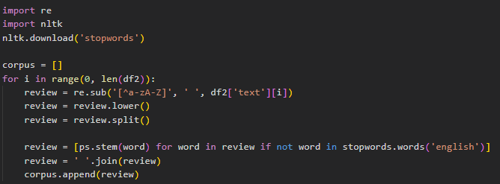
Fig 3.4: Code for stemming and removing stopwords
Figure 3.4 above depicts the code used to stem words in order to restrict the word range. After the words have been stemmed, stop words are deleted because they are unlikely to be relevant for training the model.
Vectorization of text data
Vectorization of text data was also undertaken because it was critical and must not be overlooked.
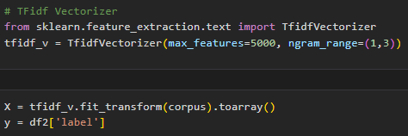
Fig 3.5: Code for vectorizing text data
Figure 3.5 above demonstrates the algorithm used to vectorize word sequences so that they can be quantitatively represented as features. This step is required in order to train a classification model utilizing the acquired dataset. The vectorizer must also be exported before it can be used in the web application.
Training and testing the machine learning algorithms
Next, we split the dataset into training and testing sets in order to generate an accurate predictive model with the code shown in fig 3.6 below
Fig 3.6: Code of train-test-split on dataset
3.6 Process Design for New System
Load Fake news dataset | Initiate data pre-processing | Build a machine model | Perform training and testing on data | Model Evaluation | Model deployment

Fig 3.7: Process design of the proposed system
3.6.1 Proposed System Model
The suggested model uses the Support Vector Machines, Logistic Regression, and PassiveAggressive Classifier methods to create the classification model.
The algorithm (step-by-step) procedures are:
Step 1: Perform Data Pre-processing
Data pre-processing is a data mining technique that involves transforming raw data into a format that is more suitable for analysis. It is an important step in the data analysis process because it can greatly impact the results of the analysis. The goal of preprocessing is to clean, transform, and integrate data from various sources so that it can be used effectively in predictive modeling, data analysis, or other statistical applications.
The steps involved in preprocessing include:
- Data cleaning: This involves handling missing values, removing outliers, and correcting errors in the data.
- Data transformation: This involves converting data from one format to another, such as converting text to numerical values.
- Data integration: This involves combining data
Step 2: Develop Machine Learning Algorithms
A machine learning algorithm is a set of instructions or rules that are used by a computer program to learn from data and make predictions or take actions. Machine learning algorithms are designed to automatically improve their performance based on experience. The machine learning algorithms used in this project are:
- Support vector machine: Support Vector Machine (SVM) is a type of supervised machine learning algorithm used for classification and regression analysis. SVM is particularly useful in problems where there is a clear separation of classes, and the goal is to find the hyperplane (a line or a plane) that best separates the classes in the feature space.
In SVM, the data is first transformed into a high-dimensional feature space, where the separation between classes can be achieved. Then, the algorithm finds the hyperplane that has the largest margin, which means that it has the maximum distance from the closest data points of each class, known as support vectors. The hyperplane that has the largest margin is called the maximum margin hyperplane.
Once the maximum margin hyperplane has been found, new data can be classified by assigning it to the class on the same side of the hyperplane as the nearest support vector. SVM can handle both linear and non-linear data, and non-linear data can be transformed into a high-dimensional feature space to make it linearly separable.
- Logistic Regression: Logistic Regression is a statistical method for analyzing a dataset in which there are one or more independent variables that determine an outcome. It is used to model relationships between variables, and is commonly used for binary classification problems, where the goal is to predict one of two possible outcomes (e.g. yes/no, true/false).
In logistic regression, the relationship between the independent variables and the dependent variable is modeled using a logistic function, which produces a probability that an event will occur. The probability is then transformed into a binary outcome using a threshold value. For example, if the probability of an event occurring is greater than 0.5, the outcome is classified as "yes", otherwise it is classified as "no".
The coefficients of the independent variables in the logistic regression model are estimated using maximum likelihood estimation. These coefficients represent the change in the log odds of the event occurring for a one-unit change in the independent variable, while controlling for the other independent variables.
Logistic regression is a simple and powerful technique that can be used for a wide range of classification problems, and it is especially useful when the relationship between the independent variables and the dependent variable is not linear. It is also a fast and efficient algorithm that can handle large datasets, and it is easy to implement and interpret.
- Passive Aggressive Classifier: The Passive Aggressive (PA) algorithm is a binary classification algorithm that belongs to the family of online learning algorithms. It was first introduced in 2006 as a linear classifier and has since been extended to handle non-linear data.
The main idea behind the PA algorithm is to update the model in a passive manner, meaning that it only makes changes when a misclassification occurs, and in an aggressive manner, meaning that it tries to correct the misclassification as quickly as possible.
The PA algorithm works by finding the optimal hyperplane that separates the two classes in the feature space. The hyperplane is updated incrementally after each misclassification, and the size of the update is proportional to the magnitude of the misclassification.
The PA algorithm has several advantages over other classification algorithms. It is easy to implement and computationally efficient, and it can handle online learning scenarios, where the data is streamed in real-time, and the model needs to be updated incrementally. The PA algorithm is also robust to noisy data and can handle large datasets.
In summary, the Passive Aggressive algorithm is a fast and efficient online learning algorithm for binary classification problems. It is a useful tool for solving real-world problems, such as spam filtering, sentiment analysis, and document classification, among others.
Step 3 & 4: Train and Test the model
Three popular algorithms that have been used for this purpose are Support Vector Machines (SVM), Logistic Regression, and Passive Aggressive Classifier (PAC). To effectively use these algorithms for predicting fake news, it is essential to first train them using a dataset that contains both real and fake news articles. During the training phase, the algorithms learn to differentiate between real and fake news by identifying patterns and features that are unique to each category. After the training phase, the algorithms are tested using a new dataset that they have not seen before. The accuracy of the algorithms is then measured by comparing their predictions with the actual labels of the articles in the testing dataset. The goal is to achieve high accuracy levels in order to ensure that the algorithms are effective in detecting and predicting fake news.
Support Vector Machines (SVM) is a popular algorithm for detecting fake news because of its ability to work well with high dimensional data. SVM works by creating a hyperplane that separates real news articles from fake news articles in a multi-dimensional feature space. During the testing phase, the algorithm predicts the label of a news article based on which side of the hyperplane it falls on.
Logistic Regression is another algorithm that has been used to predict fake news. Logistic Regression is a classification algorithm that works by estimating the probability of an event occurring. In the context of fake news detection, Logistic Regression estimates the probability of a news article being fake based on its features. During the testing phase, the algorithm predicts the label of a news article based on the probability estimate.
Passive Aggressive Classifier (PAC) is a popular algorithm for online learning tasks. PAC works by updating its model parameters as new data becomes available. In the context of fake news detection, PAC can be used to classify news articles as real or fake based on their features. During the testing phase, the algorithm predicts the label of a news article based on its learned model parameters.
In conclusion, the training and testing of Support Vector Machines (SVM), Logistic Regression, and Passive Aggressive Classifier (PAC) are essential steps in predicting and detecting fake news.

Step 5: Evaluate the predictive system
Accuracy, F1-score, and Confusion Matrix are commonly used evaluation metrics for assessing the performance of a fake news prediction model.
- Accuracy: Accuracy is the most straightforward metric and it measures the fraction of correct predictions made by the model over the total number of predictions. It is calculated as the ratio of the number of correct predictions to the total number of predictions.
- F1-Score: The F1-score is a measure of the balance between precision and recall. Precision measures the proportion of true positive predictions, while recall measures the proportion of positive cases that were correctly identified. The F1-score is the harmonic mean of precision and recall and it gives a good indication of the overall performance of the model.
- Confusion Matrix: A confusion matrix is a table that is used to evaluate the performance of a classification model. It provides a visual representation of the true positive (TP), false positive (FP), true negative (TN), and false negative (FN) predictions made by the model. Based on these values, several other evaluation metrics can be calculated, including accuracy, precision, recall, and F1-score.
Step 6: Deploy the model to a web app
The model was deployed with Streamlit. Streamlit is an open-source Python library that makes it easy to build and deploy machine learning models as web applications. To deploy the fake news prediction model using Streamlit, we followed the following steps:
- Installing Streamlit: You can install Streamlit using pip by running the following command: "pip install streamlit"
- Writing the Code: Write a Python script that loads your fake news prediction model and creates an interface for it using Streamlit. Streamlit provides a simple and intuitive syntax for building interactive applications, allowing you to add widgets, such as text input fields, buttons, and plots, to the user interface.
- Running the Application: To run the application, simply run the script using the Streamlit command-line tool: "streamlit run your_script.py"
The system model flowchart
dataset
Perform data pre-processing
Develop ML algorithms
Train the model
Test the model
Evaluate the predictive system
Deploy the model to a web app
load dataset

Fig 3.8: The system model flowchart for new predictive system
3.6.2 Use Case Diagram
Type in the text of the news article
Get a prediction on whether the news is true or false
FAKE NEWS PREDICTION

Fig 3.9: Use case diagram for the new system
The use case diagram for the web application's user interface is shown in Figure 3.9. The user will be able to submit the text equivalent of the news they wish to verify. The user will then have the opportunity to learn if the given piece of news is real or fake.
3.7 System Specification
Creating machine learning models requires a system with sufficient computational resources and appropriate software.
Some key system specifications for creating machine learning models are:
- A powerful CPU or GPU for data processing and model training
- Sufficient RAM to handle large datasets
- A high-speed storage device for storing and accessing data
- A software framework for machine learning, such as TensorFlow or PyTorch
- A programming language for implementing the machine learning algorithms, such as Python
- A development environment for coding and testing the models, such as Jupyter Notebook or an Integrated Development Environment (IDE) like Visual Studio Code or PyCharm.
- A cloud deployment service such as Streamlit, Heroku, Railway, etc.
The specific system specifications required will depend on the complexity of the machine learning models being developed and the size of the datasets being used.
CHAPTER FOUR
RESULTS AND DISCUSSION
4.1 Introduction
The model is implemented by creating an online web application that allows users to provide comments by entering news articles. After entering the news content into the web application, it is sent to the backend, where the model is saved. When the backend receives the text, the model predicts the outcome of the news and delivers the response back to the frontend, where the result is shown. The degree of accuracy provided by this approach is expressly dependent on the dataset utilized to perform the prediction operation. The web application functions more as a conduit through which data is passed to the machine learning model; the model checks itself to see if there is any resemblance in the dataset used in its development; and it then learns from previously accessible data obtained from the dataset used. Finally, it returns the right result to the user. The web application developed in this study was placed in the cloud, which means it is readily available online and can be accessed at any time and from any location. Users of this new system may test anytime they like, which increases the model's capacity to learn new things about the various news articles presented to it. The ability for the model to genuinely experience learning at its best and hence increase efficiency made cloud deployment very necessary.
4.2 Results
We used three standard machine learning algorithms to predict fake news in the Fake and Real News dataset to compare the performance of distinct ML techniques: Support Vector Machine (SVM), Logistic Regression (LR), and PassiveAggressive Classifier (PAC). Based on the parameters we've supplied; we may select the optimal ML approach for predicting fake news. Measures such as accuracy, precision, sensitivity, specificity, and confusion matrix were used to evaluate the classification technique.

4.2.1 Confusion Matrix for Support Vector Machine Algorithm
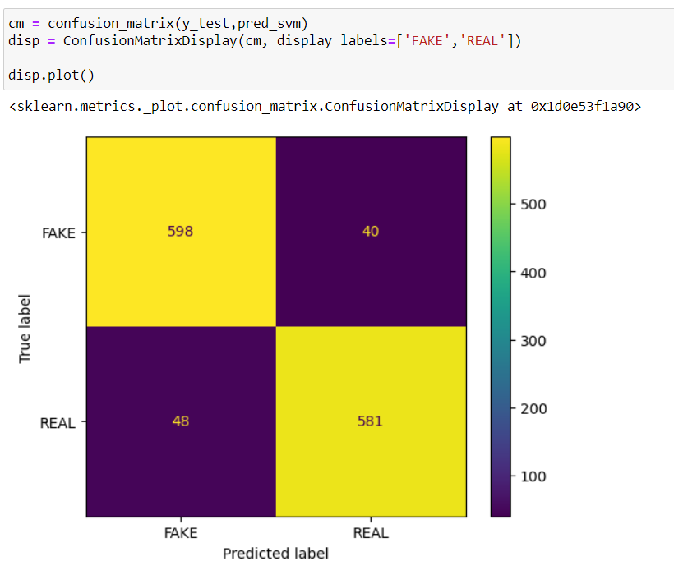
Fig 4.0: Performance of Support Vector Machine model on testing data
4.2.2 Confusion Matrix for Logistic Regression Algorithm
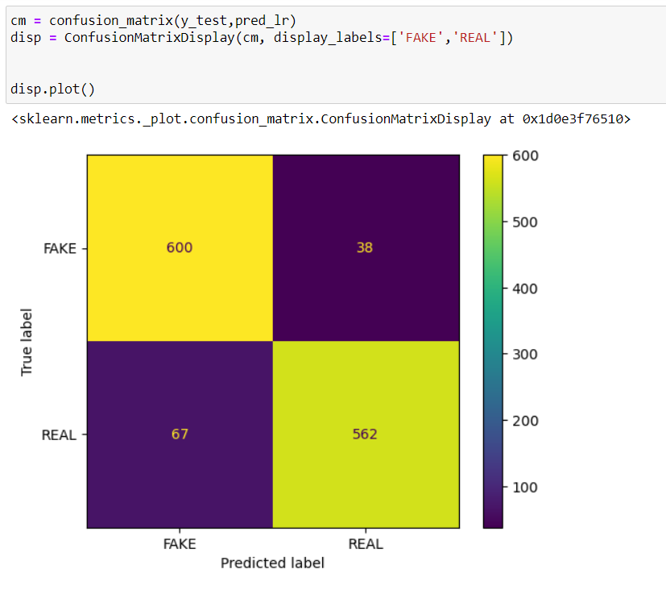
Fig 4.1: Performance of Logistic Regression model on testing data
4.2.3 Confusion Matrix for Passive Aggressive Classifier Algorithm
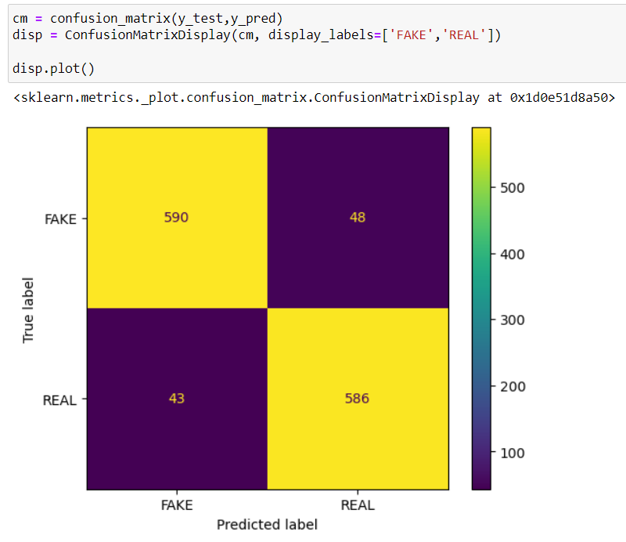
Fig 4.2: Performance of Passive Aggressive Classifier model on testing data
4.2.4 Accuracy for Support Vector Machine (SVM) model
The Support Vector Machine model gave us a training accuracy of 93%, as seen in Fig. 4.3. As a result, it would be challenging to create an accurate machine learning model. It also took a relatively longer time to train the model using SVM.
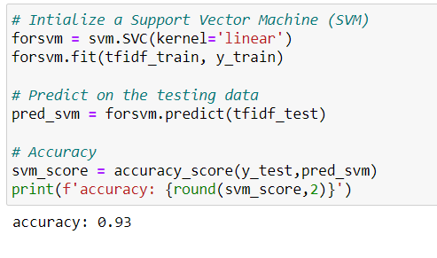
Fig 4.3: Accuracy code snippet for SVM model
4.2.5 Accuracy for Logistic Regression (LR) model
The training accuracy of the Logistic Regression model was 95%, as shown in Fig. 4.4. For the best accuracy outcome, all models must be trained.
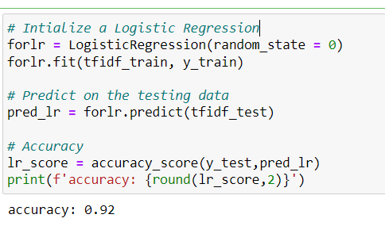
Fig 4.4: Accuracy code snippet for LR model
4.2.6 Accuracy for Passive Aggressive Classifier (PAC) model
The Passive Aggressive Classifier model, which we used to train our dataset, had the greatest training accuracy of the other models at 99%, as shown in Fig. 4.5.
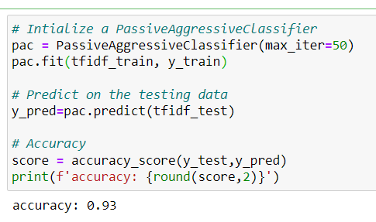
Fig 4.5: Accuracy code snippet for PAC model
4.2.7 Precision, Sensitivity and Specificity Evaluation
By listing the Precision, Sensitivity, Specificity, and Accuracy for each of the three machine learning models used in this study, the results are summarized in the table below.
MODEL | PRECISION | SENSITIVITY | SPECIFICITY | ACCURACY (%)
Support Vector Machine | 0.93 | 0.90 | 0.94 | 0.93
Logistic Regression | 0.94 | 0.89 | 0.94 | 0.92
Passive Aggressive | 0.93 | 0.93 | 0.94 | 0.93

Table 4.0: Summary of evaluation metrics
Prior to examining the model's accuracy and sensitivity, the specificity of the model is given greater thought when analyzing the machine learning algorithms. This is due to the fact that, in terms of the breadth of detecting fake news, the repercussions of identifying a fake news headline as real are far worse than those of identifying a real news item as fake. As can be seen, the Support Vector Machine and Passive Aggressive models had the highest specificity among the three machine learning algorithms, at 94% and 100%, respectively. The model with the highest sensitivity, at 99%, is Passive aggressive. According to Fig. 4.6, the Passive Aggressive model may have slightly higher accuracy than other models, but sensitivity and specificity are given more weight than accuracy alone. In light of this, it was decided to deploy the Passive Aggressive model in the web application.
4.3 Discussion of Results
This stage explains the necessary testing and implementation of the Passive Aggressive model on the web application. After model evaluation, the model is saved and exported as a pickle file so that it can be deployed on the web application.
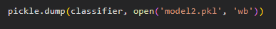
Fig 4.6: Code for exporting the model

Web Application Development
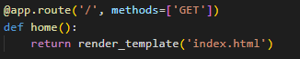
Fig 4.7: Code for default route of Flask web app
The web application's default route is implemented as shown in the aforementioned code snippet. The user sees the rendered and displayed HTML webpage when the default route is requested.
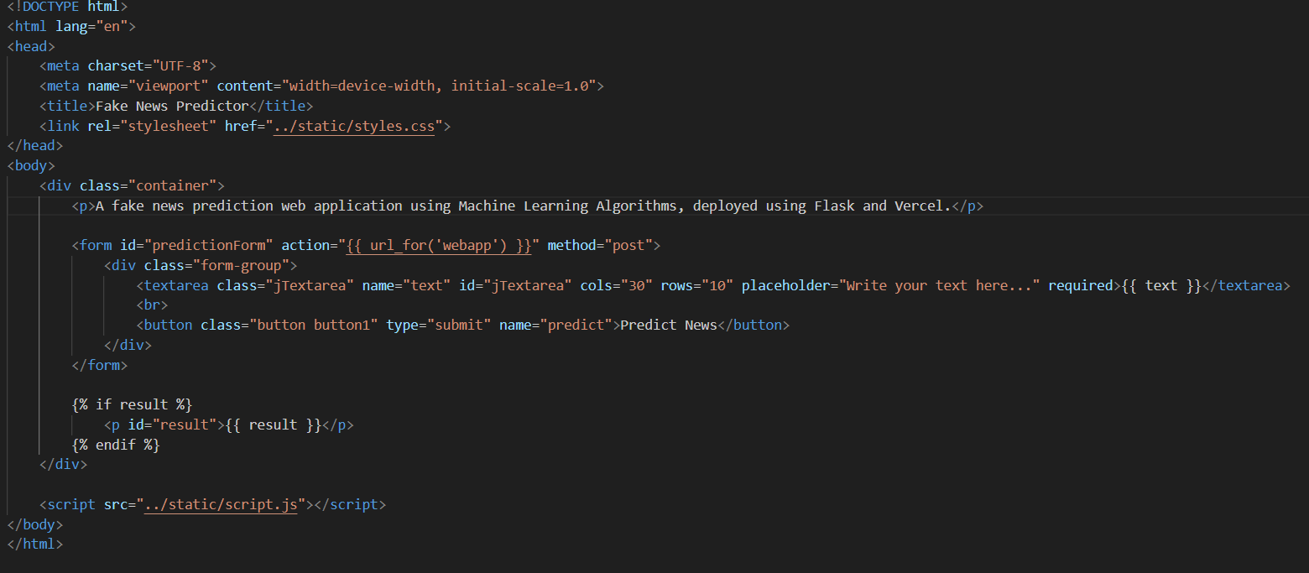
Fig 4.8: Code snippet for index.html
A portion of the HTML code for the webpage displayed at the default route is shown in Figure 4.9. This webpage's primary function is to receive text data from users and send it to the back end via a POST request so that it can be predicted as well as display the result to users.

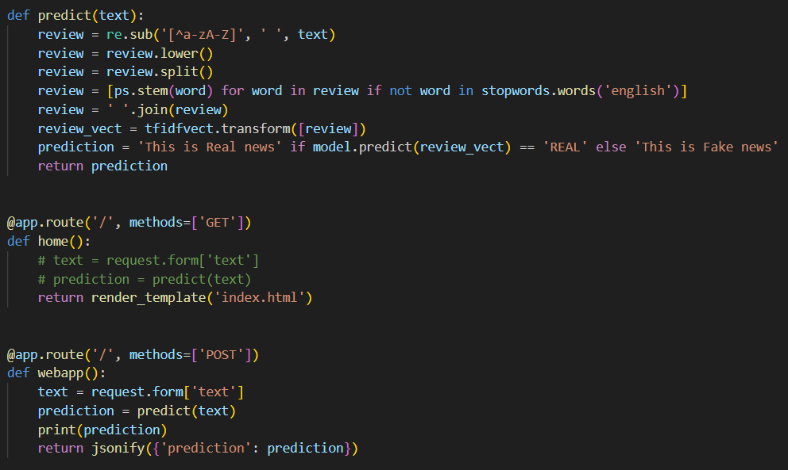
Fig 4.9: Code snippet for predict route for the web app
The coding for the web application's predict route is displayed in the aforementioned code snippet. The text vectorizer and machine learning model are imported for usage in this route in order to make predictions. Before producing a prediction based on the text data from the POST request sent from the preceding webpage, some simple data cleaning is done on the text. The user is then presented with the expected label via index.html.
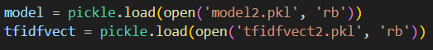
Fig 4.9a: Code for importing trained model and vectorizer
Finally, the code that was utilized to incorporate the text vectorizers and classification models that had previously been exported into the web application is shown in the figure above.

4.4 Conclusion
The model has finally been deployed onto the web application using Streamlit. The web application was also deployed to the cloud for easy accessibility.

Fig 4.9b: User enters news content that is likely to be fake
Figure 4.9b demonstrates a user entering a news story into a web application that is highly likely to be fake.
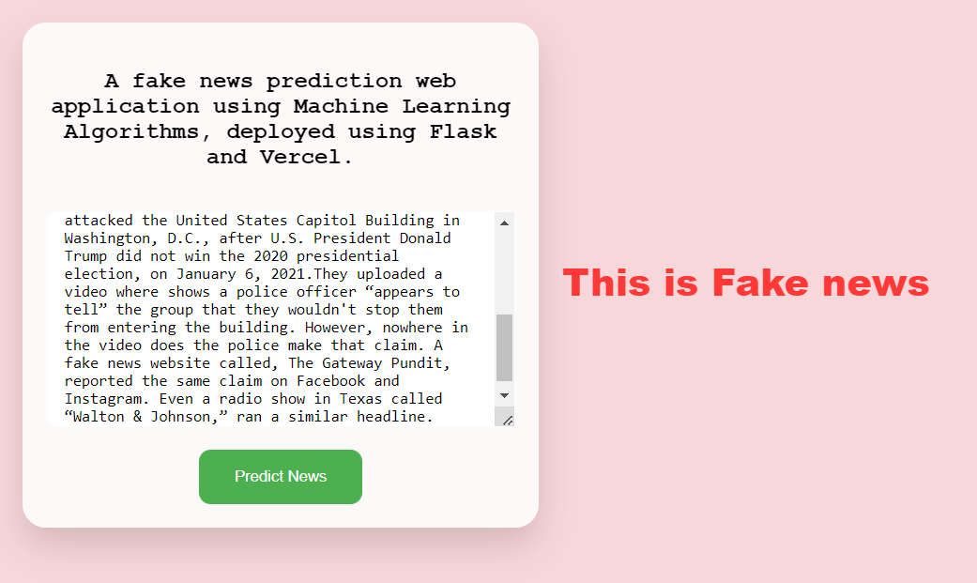
Fig 4.9c: Web application result (for Fake news)
Figure 4.9c shows that the web application can identify a certain news story as a fake.


Fig 4.9d: News headline related to Border Crisis
We will enter the headline and the body of the news article in Fig 4.9d to test if our web application can effectively make an accurate prediction.

Fig 4.9e: User enters news content that is likely to be real from Fig 4.9e
Figure 4.9e demonstrates a user entering a news story into a web application that is highly likely to be real.

Fig 4.9f: Web application result (for Real news)
Figure 4.9f shows that the web application can identify a certain news story as a real news.

CHAPTER FIVE
SUMMARY, CONCLUSION AND RECOMMENDATION

5.1 Introduction
This chapter gives a succinct description of the project before drawing some conclusions. On the basis of the analysis completed and the literature reviewed, it also makes some recommendations.

5.2 Summary
This project is composed of a total of five chapters. The purpose of the work, as well as its aims, constraints, and scope, are all introduced in the first chapter. The difficulty with the current system, a study of related project literature, and summary were all covered in the second chapter. The methods utilized to collect, analyze, and create the new system were all described in detail in the third chapter. There was also an explanation of the new system's design, which is intended to address the shortcomings of the existing system. The application of the program and its testing were covered in the fourth chapter. Last but not least, the highlighted overview and conclusion of the work done on this project are included in chapter five.
The project is built on a fake news detection model that is designed to make it easier to determine if a news story is authentic or fake and to comprehend the effects of fake news. Because of the current system's obvious flaws, it was essential to develop a replacement that could improve the present process more effectively. As a result, machine learning was included into the new system. Users may put news stories into the web application created for this model and check the veracity of the news.

5.3 Conclusion
The widespread dissemination of false information online will have negative effects on society. Readers who are misled by fake news will be so confused that they will believe something that is false to be real. This is the risk posed by false news, as many in modern society are still unable to tell the difference between the two in their day-to-day activities. By using machine learning to determine if news is fake or not, this issue can, however, be resolved. The main contribution of this project is support for the idea that machine learning could be useful in a novel way for the task of classifying fake news. Three different feature extraction techniques, including the TFIDF Vectorizer and Word Embedding, were used in this project. In order to categorize news as real or fake, many classification models, including Support Vector Machine, Logistic Regression Classifier, and Passive Aggressive Classifier, have been tried, with the latter approach emerging as the best. A combination of machine learning and natural language processing approaches is adopted after considering the results of these models. A trained machine learning model is connected to a user interface that has been created. For the purpose of predicting user-inputted news, a passive aggressive classifier with a TF-IDF vectorizer is trained. This platform allows users to input news, and it will assess whether or not it is real. In order to achieve better results, we plan to use this and other machine learning algorithms on larger datasets in our next work.

5.4 Recommendation
We have demonstrated via the work done on this project that machine learning can detect sometimes subtle linguistic patterns that may be challenging for people to discern. In this project, there are three potential ways that the following stages will be taken. Enhancing and expanding the dataset size is the first area in which this project might be made better. For the model to be free of any bias based on certain patterns in the source, we believe that more data would be helpful. In addition, it is uncertain whether or whether the size of our dataset is adequate.

Comparing this project against people carrying out the same activity is the second way it might be improved. Evaluating the accuracy would be helpful in determining whether or not the dataset is indicative of how challenging it is to distinguish between fake and authentic news. If people are more accurate than the model, we might need to identify more misleading instances of fake news. We recognize that this is only one tool among several that would be necessary for an all-encompassing system for identifying false news, and we anticipate that its accuracy will never be flawless. If, however, it is already more accurate than a person at the same activity, then it could be useful as a stand-alone tool. The sentences or trigrams that a person would point out if asked what they based their categorization choice on would be interesting to compare in addition to comparing the accuracy to human accuracy. Then, we might calculate how close these patterns are to those that people perceive as being suggestive of both fake and real news.
This program is merely one of several that would be required in a bigger toolkit that might serve as a highly effective fake news detector. A fact detector and a stance detector may be among the additional tools that would need to be constructed. There would need to be some sort of model that integrates all of the tools and figures out how to weigh each one in its final judgment in order to merge all of these procedures.

REFERENCES
Agarwal, V., Sultana, H. P., Malhotra, S., & Sarkar, A. (2019). Analysis of Classifiers for Fake News Detection. Procedia Computer Science, 165, 377–383. https://doi.org/10.1016/j.procs.2020.01.035
Ahmad, T., Faisal, M. S., Rizwan, A., Alkanhel, R., Khan, P. W., & Muthanna, A. (2022). Efficient Fake News Detection Mechanism Using Enhanced Deep Learning Model. Applied Sciences, 12(3), 1743. https://doi.org/10.3390/app12031743
Ahmad, I., Yousaf, M., Yousaf, S., & Ahmad, M. O. (2020). Fake News Detection Using Machine Learning Ensemble Methods. Complexity, 2020, 1–11. https://doi.org/10.1155/2020/8885861
Aldwairi, M., & Alwahedi, A. (2018). Detecting Fake News in Social Media Networks. Procedia Computer Science, 141, 215–222. https://doi.org/10.1016/j.procs.2018.10.171
Bisaillon, C. (2020, March 26). Fake and real news dataset. Kaggle. https://www.kaggle.com/datasets/clmentbisaillon/fake-and-real-news-dataset
Copeland, M. (2021, July 17). The Difference Between AI, Machine Learning, and Deep Learning? NVIDIA Blog. https://blogs.nvidia.com/blog/2016/07/29/whats-difference-artificial-intelligence-machine-learning-deep-learning-ai/
Domonoske, C. (2016, November 23). Students have ’dismaying’ inability to tell fake news from real, study finds. NPR. https://www.npr.org/sections/thetwo-way/2016/11/23/503129818/study-finds-students-have-dismaying-inability-to-tell-fake-news-from-real
Dornadula, V. N., & Geetha, S. (2019). Credit Card Fraud Detection using Machine Learning Algorithms. Procedia Computer Science, 165, 631–641. https://doi.org/10.1016/j.procs.2020.01.057
Eling, M., Nuessle, D., & Staubli, J. (2021). The impact of artificial intelligence along the insurance value chain and on the insurability of risks. The Geneva Papers on Risk and Insurance - Issues and Practice, 47(2), 205–241. https://doi.org/10.1057/s41288-020-00201-7
Hossain, E., Nadim Kaysar, M., Jalal Uddin Joy, A. Z. M., Mizanur Rahman, M., & Wahidur Rahman. (2021). A Study Towards Bangla Fake News Detection Using Machine Learning and Deep Learning. Advances in Intelligent Systems and Computing, 79–95. https://doi.org/10.1007/978-981-16-5157-1_7
Imamura, T. (2021). 19 Real Events Caused by Fake News in the US | Marubeni Corporation. Marubeni. https://www.marubeni.com/en/research/potomac/backnumber/19.html
Kang, C., & Goldman, A. (2016, December 13). In Washington Pizzeria Attack, Fake News Brought Real Guns. The New York Times. https://www.nytimes.com/2016/12/05/business/media/comet-ping-pong-pizza-shooting-fake-news-consequences.html
Khan, J. Y., Khondaker, M. T. I., Afroz, S., Uddin, G., & Iqbal, A. (2021). A benchmark study of machine learning models for online fake news detection. Machine Learning with Applications, 4, 100032. https://doi.org/10.1016/j.mlwa.2021.100032
Khanam, Z., Alwasel, B. N., Sirafi, H., & Rashid, M. (2021). Fake News Detection Using Machine Learning Approaches. IOP Conference Series: Materials Science and Engineering, 1099(1), 012040. https://doi.org/10.1088/1757-899x/1099/1/012040
Lai, C. M., Chen, M. H., Kristiani, E., Verma, V. K., & Yang, C. T. (2022). Fake News Classification Based on Content Level Features. Applied Sciences, 12(3), 1116. https://doi.org/10.3390/app12031116
Mazzeo, V., Rapisarda, A., & Giuffrida, G. (2021). Detection of Fake News on COVID-19 on Web Search Engines. Frontiers in Physics, 9. https://doi.org/10.3389/fphy.2021.685730
Mokhtar, M. S., Jusoh, Y. Y., Admodisastro, N., Pa, N. C., & Amruddin, A. Y. (2019). Fakebuster: Fake News Detection System Using Logistic Regression Technique in Machine Learning. International Journal of Engineering and Advanced Technology, 9(1), 2407–2410. https://doi.org/10.35940/ijeat.a2633.109119
Okoro, E., Abara, B., Umagba, A., Ajonye, A., & Isa, Z. (2018). A hybrid approach to fake news detection on social media. Nigerian Journal of Technology, 37(2), 454. https://doi.org/10.4314/njt.v37i2.22
Paltrinieri, N., Comfort, L., & Reniers, G. (2019). Learning about risk: Machine learning for risk assessment. Safety Science, 118, 475–486. https://doi.org/10.1016/j.ssci.2019.06.001
Preston, S., Anderson, A., Robertson, D. J., Shephard, M. P., & Huhe, N. (2021). Detecting fake news on Facebook: The role of emotional intelligence. PLOS ONE, 16(3), e0246757. https://doi.org/10.1371/journal.pone.0246757
Raza, S., & Ding, C. (2022). Fake news detection based on news content and social contexts: a transformer-based approach. International Journal of Data Science and Analytics, 13(4), 335–362. https://doi.org/10.1007/s41060-021-00302-z
Silva, C. V., Silva Fontes, R., & Colaço Júnior, M. (2020). Intelligent Fake News Detection: A Systematic Mapping. Journal of Applied Security Research, 16(2), 168–189. https://doi.org/10.1080/19361610.2020.1761224
Wang, J., Mao, H., & Li, H. (2022). FMFN: Fine-Grained Multimodal Fusion Networks for Fake News Detection. Applied Sciences, 12(3), 1093. https://doi.org/10.3390/app12031093
Wardle, C. (2021, March 29). Fake news. It’s complicated. First Draft. https://firstdraftnews.org/articles/fake-news-complicated/
Watts, N. (2018, July 5). 5 Types of ’Fake News’ and Why They Matter. Ogilvy. https://www.ogilvy.com/ideas/5-types-fake-news-why-they-matter
Yu, S., Chen, Y., & Zaidi, H. (2021). AVA: A Financial Service Chatbot Based on Deep Bidirectional Transformers. Frontiers in Applied Mathematics and Statistics, 7. https://doi.org/10.3389/fams.2021.604842

